**Local Air Quality Study – Prince George, BC, 2018**

Introduction

The city of Prince George, located in Northern British Columbia, has a population of approximately 74,000 (BCStats, 2016) and is situated at the confluence of the Nechako and Fraser Rivers in a valley approximately 150 meters below the BC Central Interior Plateau (Fig. 1). The city has gained notorious reputation for poor air quality and some of the highest pollutant levels in BC. This study particularly looks at the PM 2.5 data gathered at Plaza 400 (marked as a red star in Fig. 1) for the year of 2018. PM2.5 is the fine particulate matter with particles smaller than 2.5 microns and comes mainly from combustion sources such as industrial operations, vehicles and wood smoke but can also be a byproduct from chemical reactions among pollutants and components of the atmosphere. Fine particulates pose significant threat to human health because their small size lets them deeply penetrate lung tissue, and in some cases even the bloodstream posing danger to lung and cardiac health.

Prince George’s air quality problems can be hypothesized as a combination of meteorology, topography and land use. Approximately 44 industrial operations currently hold air emissions permits in and around Prince George which includes three pulp mills, an oil refinery, two asphalt plants, a host of sawmills, wood product plants and chemical operations (Fig. 2). Geographically the city is in a bowl-shaped valley, 450 km from the Pacific Ocean, and more than 500 km and 600 km, respectively, from the nearest major urban centers of Vancouver and Edmonton; making Prince George isolated from anthropogenic emission sources outside its own airshed. Additionally, atmospheric stagnation events due to anticyclonic conditions, thermal inversions and light winds in the valley often result in aggravated air conditions. Frequent summer-time forest fires in the province also degrade air quality in Prince George. This paper aims to detect and exemplify some of these instances from the diurnal and seasonal data acquired in 2018, discuss any anomalies, sources, sinks and exceedances in the scope of Prince George’s PM 2.5 concentration.

Data Acquisition and Observations:

The PM 2.5 data and PM 2.5 24-hour running average data was acquired from the Air Quality Health Index (AQHI) data archive found on the BC Air Quality website. The data reported all PM2.5 concentrations in µg m-3 and was compared with the Canada Wide Standard (CWS) for PM2.5 at 28 µg m-3 for a 24-hour running average to detect exceedances and their potential explanation.

First the raw data was plot as a timeseries of PM2.5 concentration against time. As seen in Fig.3 1, there is a largely noticeable peak around the summer months, particularly mid-August to mid-September that reaches almost 630 µg m-3. Other noticeable peaks occur around April at 170 µg m-3 and others in February, June and October each around 100 µg m-3. Graph 1 alone does not provide a holistic view of the trend in PM 2.5 and so further analysis was carried out by splitting the data into seasonal trends. Seasons are defined as the following:

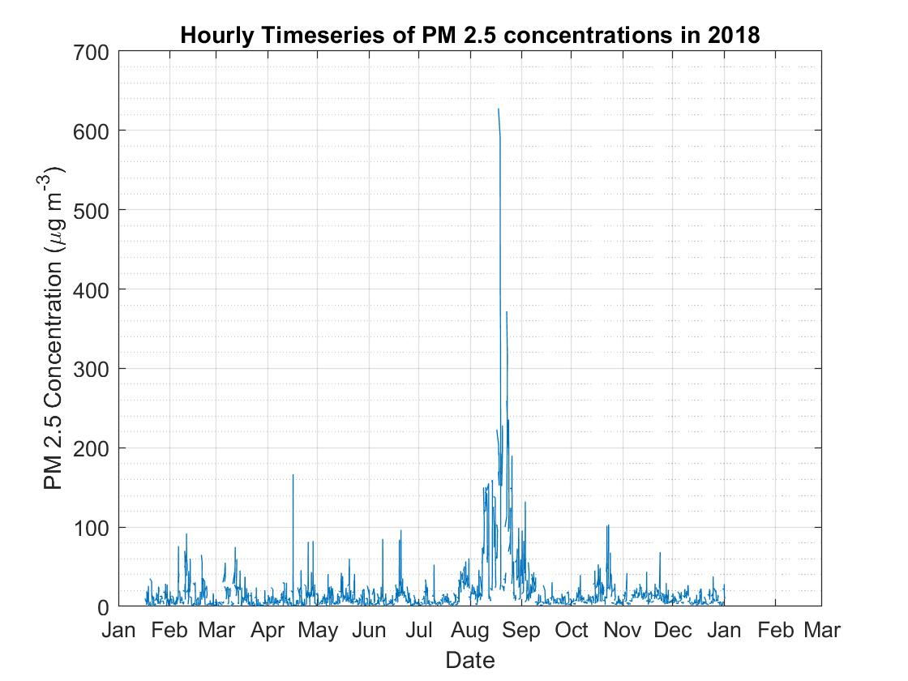

Graph 1:Timeseries of the raw PM 2.5 concentration in 2018. Data starting on January 16, 2018 upto January 16,2019

* Winter- January, February, March
* Spring- April, May, June
* Summer- July, August, September
* Fall – October, November, December

Graphs 2 through 5 below show the raw PM 2.5 data split into 4 seasons and represented as boxplots that show the range of PM 2.5 concentrations through the course of the day, for that season.

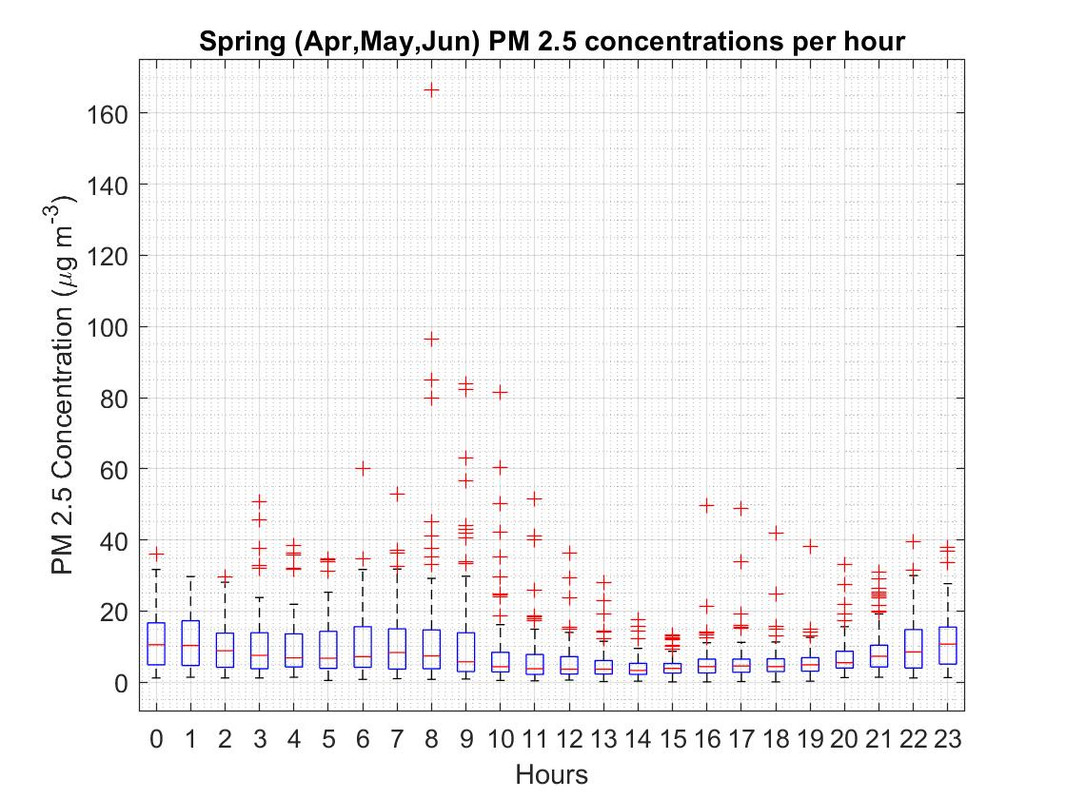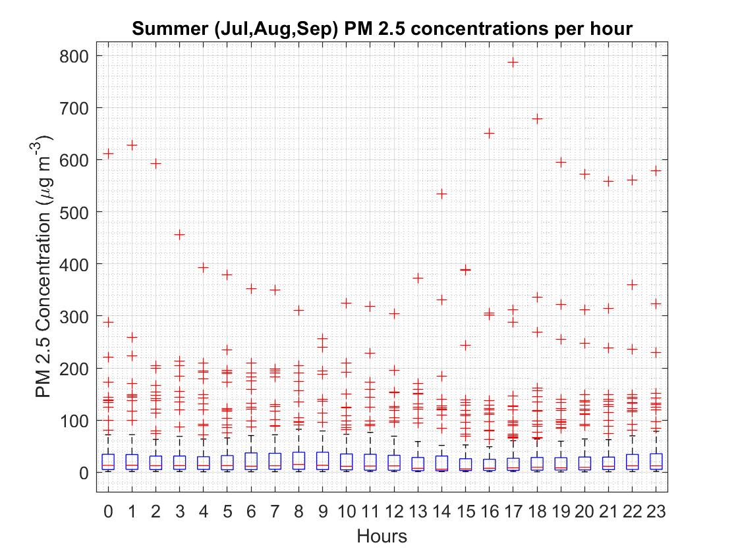

Graph 3: Distribution of PM 2.5 concentrations for spring 2018

Graph 3: Distribution of PM2.5 concentrations for summer 2018

Discussion:

Due to the low population density of northern BC and the absence of urban agglomerations, there are few ambient PM measurements in general, and a lack of background PM stations in particular. Most of the few existing PM measurement stations in northern BC are located close to local emission sources and cannot be treated as remote background stations. [Vingarzan (2007](https://www-tandfonline-com.ezproxy.library.ubc.ca/doi/full/10.1080/10962247.2013.789091?scroll=top&needAccess=true)Vingarzan, R. 2007. *Ambient Particulate Matter Concentrations in Canada and Background Levels*, Vancouver: Environment Canada, Meteorological Services Branch. [[Google Scholar]](http://scholar.google.com.ezproxy.library.ubc.ca/scholar_lookup?hl=en&publication_year=2007&author=R.+Vingarzan&title=+Ambient+Particulate+Matter+Concentrations+in+Canada+and+Background+Levels+)) mentioned this problem and also reviewed available PM background levels from literature that are primarily large-scale averages for the United States and Western Canada ([Trijonis et al., 1990](https://www-tandfonline-com.ezproxy.library.ubc.ca/doi/full/10.1080/10962247.2013.789091?scroll=top&needAccess=true)Trijonis, J.C., Malm, W.C., Pitchford, M., Charlson, R. and Husar, R. 1990. *Natural Background Conditions for Visibility/Aerosols. NAPAP Report 24, section 3.5*, Washington, DC: National Acid Precipitation Program. [[Google Scholar]](http://scholar.google.com.ezproxy.library.ubc.ca/scholar_lookup?hl=en&publication_year=1990&author=J.C.+Trijonis&author=W.C.+Malm&author=M.+Pitchford&author=R.+Charlson&author=R.+Husar&title=+Natural+Background+Conditions+for+Visibility%2FAerosols.+NAPAP+Report+24%2C+section+3.5+); [U.S. Environmental Protection Agency [EPA], 1996](https://www-tandfonline-com.ezproxy.library.ubc.ca/doi/full/10.1080/10962247.2013.789091?scroll=top&needAccess=true)U.S. Environmental Protection Agency. 1996. *Air Quality Criteria for Particulate Matter*, Washington, DC: U.S. Environmental Protection Agency. [[Google Scholar]](http://scholar.google.com.ezproxy.library.ubc.ca/scholar_lookup?hl=en&publication_year=1996&author=+U.S.+Environmental+Protection+Agency&title=+Air+Quality+Criteria+for+Particulate+Matter+)). In these studies, background concentrations have ranges of 1–4 µg/m3 for PM2.5

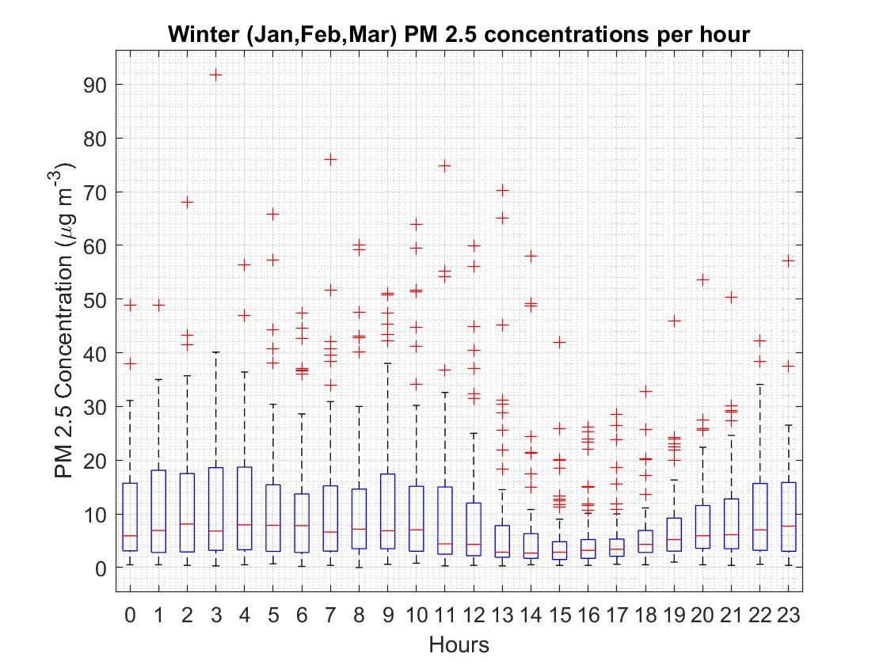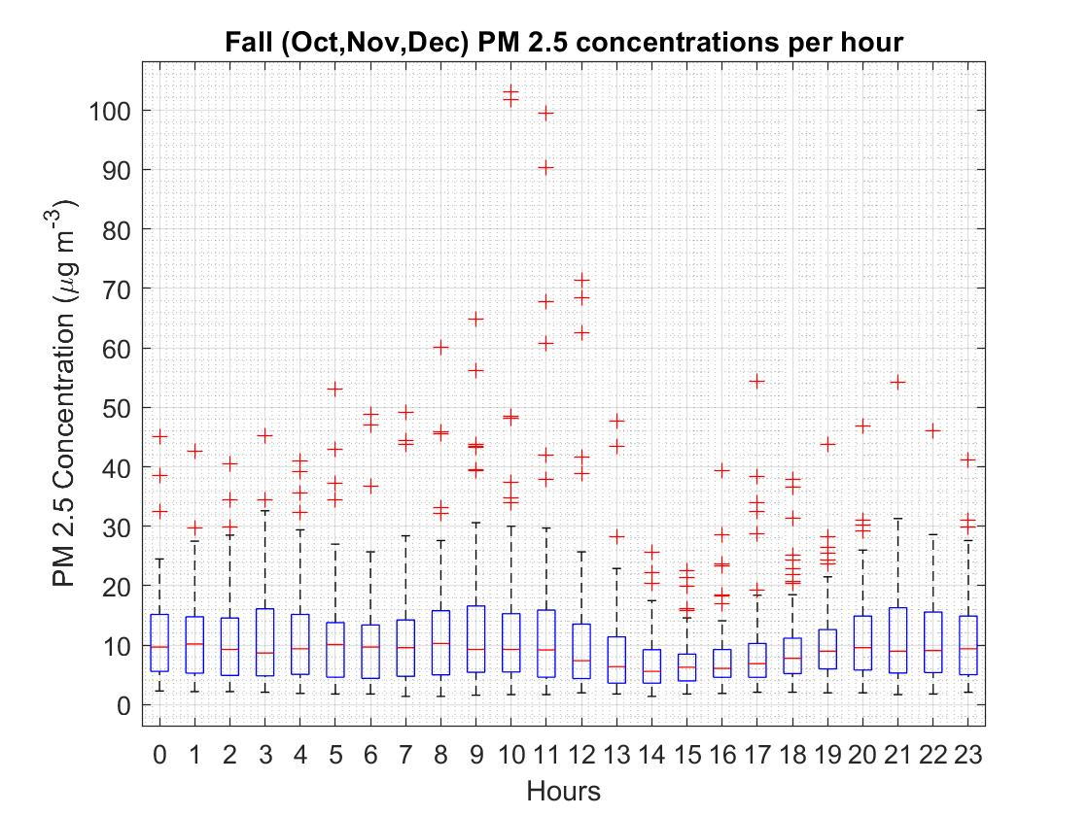

Graph 4: Distribution of PM2.5 concentrations for fall 2018

Graph 5: Distribution of PM2.5 concentrations for winter 2018

Two pulp mills and one oil refinery are less than 4 km northeast of Plaza and contribute significantly to ambient PM (both PM2.5 and PM10) measured there, especially when winds are from the northeast to southeast direction.

 This result is reasonable as dust emissions are suppressed for wet as well as dry conditions during the winter season due to snow cover. Furthermore, the production of organic aerosols from biogenic sources (mainly forests) is to a large extent suppressed during winter (e.g., [Kulmala et al., 2001](https://www-tandfonline-com.ezproxy.library.ubc.ca/doi/full/10.1080/10962247.2013.789091?scroll=top&needAccess=true)Kulmala, M. 2001. Overview of the international project on biogenic aerosol formation in the boreal forest (BIOFOR). *Tellus*, 53B: 324–43. doi:10.1034/j.1600-0889.2001.530402.x[[Crossref]](https://www-tandfonline-com.ezproxy.library.ubc.ca/servlet/linkout?suffix=CIT0016&dbid=16&doi=10.1080%2F10962247.2013.789091&key=10.1034%2Fj.1600-0889.2001.530402.x), , [[Google Scholar]](http://scholar.google.com.ezproxy.library.ubc.ca/scholar_lookup?hl=en&publication_year=2001&pages=324-43&author=M.+Kulmala&title=Overview+of+the+international+project+on+biogenic+aerosol+formation+in+the+boreal+forest+%28BIOFOR%29)) and forest fires generally do not occur during winter in this region.

The PM2.5 summer peak for dry conditions is thought to be primarily associated with forest fires and stagnation during anticyclonic periods resulting in fumigation events. The large variance of summer values supports this assumption

The provincial objectives for PM2.5 are 25 µg/m3 - for the 98th percentile of one year’s daily means and 8 µg/m3 for the full annual mean.

In 2014, 24 exceedances of the numerical 24-hour Provincial PM2.5 objective were observed at Plaza 400 (Figure 3). The majority of these exceedances (58%) occurred from July-September as a result of wildfires (Figure 4), including the Chelaslie River wildfire that burned an unprecedented 1331 km2 of the Entiako Provincial Park just 200 km southwest of the station. The remaining exceedances generally occurred during late winter periods when meteorological conditions can create stagnant conditions and wood burning appliances and other sources emit particulates that become trapped in the local air. Seasonal variations in PM2.5 concentrations are evident in the 2014 time series of both sites (Figure 4). The plot identifies the summer exceedances linked to wildfires and the winter events linked to meteorological conditions. The majority of exceedances occurred between July and September with other exceedance events occurring in November and February.

Even though this precipitation effect is well known (since precipitation efficiently suppresses dust mobilization and hygroscopic aerosols are washed out), these results also support the reasonableness of the LPSC method. The PM2.5 fall values are an exception as background concentrations for dry and wet conditions do not differ significantly within the 95% confidence interval. Fall PM2.5 values for Plaza are 2.7 ± 0.6 µg/m3 for dry conditions and 2.8 ± 0.5 µg/m3 for wet conditions,

Prince George. This city has gained the dubious distinction of being a “bad air town,” with some of the highest pollutant levels in British Columbia. Our pollutants include: total reduced sulphur, sulphur dioxide, nitrogen dioxide, ozone, carbon monoxide and particulate matter. The BC Lung Association’s 2007 State of the Air report positions Prince George as having the highest levels of PM2.5 (fine particulate matter with particles smaller than 2.5 microns, or about two one-thousandths of a millimetre) in the province.   
This fine particulate—tiny bits of matter in the air—comes mainly from combustion sources (industrial operations, vehicles and wood smoke)—but it also comes from chemical reactions among pollutants and components of the atmosphere. Fine particulates pose significant concern to human health because they can bypass the lung’s defenses and deeply penetrate into lung tissue.  
Prince George’s “bad air” reputation, and one-too-many air-quality advisories, led to a phone call I received from a friend. “Aren’t you sick of the air around here? Don’t you want to do something about it?” These words led to the formation of PACHA (People’s Action Committee for Healthy Air), a non-profit society whose primary goal is to advocate for better air in Prince George.  
Since forming in 2006, we have learned that approximately 44 industrial operations currently hold air emissions permits in and around Prince George. This list includes three pulp mills, an oil refinery, a host of sawmills, wood product plants and chemical operations.